1. **Screenshots**
   1. **Screen 1 : Add a new Allegation Screen**

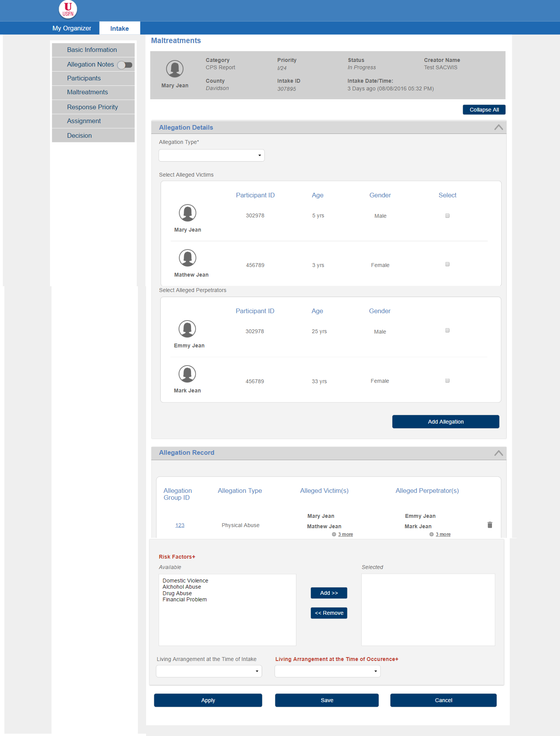

* + 1. **Screen Fields**

| **Class.Attribute Name** | **Display Name** | **Type** | **Align** | **Size** | **Read**  **Only** | **Calculation** | **Edit Mask** | **To Be**  **UI Validation** |
| --- | --- | --- | --- | --- | --- | --- | --- | --- |
| N/A | Maltreatments | Screen header | L | 50 | T | N/A | N/A | N/A |
| INTAKE.Intakename | N/A | Display text | L | 100 | T | N/A | First Name, Last Name under the participant picture | System Generated  Not editable |
| INTAKE.categoryCode | Category | Display Text | L | 30 | T | domain code=IntakeCategory | N/A | System Generated  Not Editable |
| INTAKE.recommendedPriority | Priority | Display Text | L | 10 | T | domain code=IntakePriority | N/A | System Generated  Not Editable |
| INTAKE.statusCode | Status | Display Text | L | 30 | T | domain code=IntakeStatus | N/A | System Generated  Not Editable |
| INTAKE.CreatedBy | Creator Name | Display text | L | 22 | T | N/A | First Name, Last Name, MI | System Generated  Not Editable |
| ALLEGATIONSETTING.allegationCounty | County | Display Text | L | 50 | T | domain code=County | N/A | System Generated  Not Editable |
| INTAKE.intakeId | Intake ID | Display Text | L | 22 | T | N/A | N/A | System Generated  Not Editable |
| INTAKE.statusDate | Intake Date/Time | Display Text | L | 25 | T | N/A | MM/DD/YYYY ##:## AM / PM | System generated  Not Editable |
| N/A | Allegation Details | Section Header | L | 50 | T | N/A | N/A | N/A |
| N/A | Allegation Type | Group label | L | 50 | T | N/A | N/A | N/A |
| Allegation.allegationType | Allegation Type | Drop Down | L | 100 | F | domain code=AllegationType | N/A | System Displayed list  User selectable |
| N/A | Selected | Mover box | L | 100 | F | N/A | N/A | User selectable |
| N/A | Select Alleged Victims | Section header | L | 100 | T | N/A | N/A | All participants added in the Participant screen should appear in this list |
| IntakeParticipant.Firstname + IntakeParticipant.Lastname | N/A | Display Text | L | 100 | T | N/A | First name, Last name under the participant picture | System Generated  Not editable |
| INTAKEPARTICIPANT.intakeParticipantId | Participant ID | Display Text | C | 22 | T | N/A | N/A | System Generated  Not editable |
| N/A | Age | Display Text | C | 3 | T | N/A | Calculate from INTAKEPARTICIPANT.birthDate | N/A |
| INTAKEPARTICIPANT.genderCode | Gender | Display Text | C | 30 | T | Domain Code =  “Gender” | N/A | System Populated  Not editable |
| N/A | Select | Checkbox | C | 30 | T | N/A | N/A | User selectable  Not mandatory |
| N/A | Select Alleged Perpetrators | Section Header | L | 100 | T | N/A | N/A | All participants added in the Participant screen should appear in this list |
| INTAKEPARTICIPANTAP.intakeParticipantAPId | N/A | Display text | C | 100 | T | N/A | First name, last name displayed under the participant picture | System Generated  Not Editable |
| INTAKEPARTICIPANT.intakeParticipantId | Participant ID | Display Text | C | 22 | T | N/A | N/A | System Generated  Not editable |
| N/A | Age | Display Text | C | 3 | T | N/A | Calculate from INTAKEPARTICIPANT.birthDate | N/A |
| INTAKEPARTICIPANT.genderCode | Gender | Display Text | L | 30 | T | Domain Code =  “Gender” | N/A | System Populated  Not editable |
| N/A | Select | Check box | C | 30 | T | N/A | N/A | User selectable  Not mandatory |
| N/A | Allegation Record | Section Header | L | 100 | T | N/A | N/A | N/A |
| Allegation.AllegationGroupId | Allegation Group ID | Display Text | L |  | F |  |  | System populated |
| ALLEGATION.allegationTypeCode | Allegation Type | Display Text | C | 100 | F | Where Allegation.AllegationGroupId=AllegationGroup.allegationGroupId,Domain code=AllegationType | N/A | System populated  Not Editable |
| INTAKEPARTICIPANTACV.intakeParticipantACVId | Alleged Victim(s) | Display Text | C | 100 | F | Where Allegation.AllegationGroupId=AllegationGroup.allegationGroupId and intakeParticipantId=Allegation.IntakePartACVId | First Name, Last Name displayed under AV’s picture | System populated |
| INTAKEPARTICIPANTAP.intakeParticipantAPId | Alleged Perpetrator(s) | Display Text | C | 100 | T | Where Allegation.AllegationGroupId=AllegationGroup.allegationGroupId and intakeParticipantId=Allegation.IntakePartAPId | First Name, Last Name displayed under AP picture | System populated |
| N/A | Risk Factors | Group Label | L | 100 | T | N/A | N/A | N/A |
| INTAKE_CHARACTERISTIC.intakeCharacteristicCode | Available | Mover box | L | 30 | T | Domain Code = “CaregiverRiskFactor” | N/A | System populated  User selectable  Not mandatory |
| N/A | Selected | Mover box | L | 100 | T | N/A | N/A | User selected |
| INTAKE.livingArrangements | Living Arrangement at the time of intake | Drop down | L | 100 | F | Domain Code = LivingArrangement where parent ref data code = NCANDS | N/A | User selected  Not required |
| ALLEGATIONSETTING.allegationLivingArrangement | Living Arrangement at the time of occurrence | Drop down | L | 100 | F | Domain Code = “LivingArrangement” where parent ref data code=NCANDS | N/A | User selected  Not Required  AFCARS/NCANDS/NYTD |

­­

* + 1. **Action Buttons/Hyperlinks**

| **Label** | **Type** | **On Click Action/Navigation** |
| --- | --- | --- |
| Add Allegation | Button | A new Allegation Group Record is added and individual Allegation records are generated and saved to the database. |
| Delete | Button | Deletes the selected record under ‘Allegation Record’ section. |
| Apply | Button | Data is saved and user remains on the screen |
| Save | Button | All cached screen data will be committed to the database. User returns to the Intake Workload Screen |
| Cancel | Button | Return to Intake Workload Screen; no newly entered data will be saved. |

* 1. **Screen 2: To edit an already existing Allegation Record.**

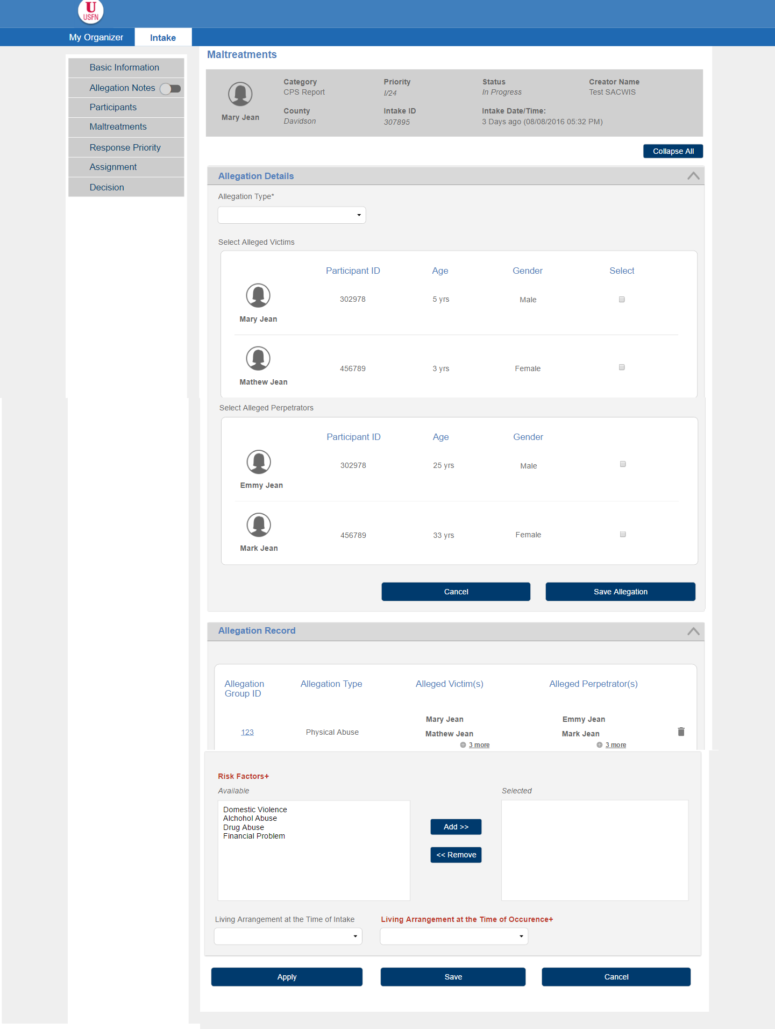

* + 1. **Screen Fields**

**Same as 1.1.1**

* + 1. **Action Buttons/Hyperlinks**

| **Label** | **Type** | **On Click Action/Navigation** |
| --- | --- | --- |
| Save Allegation | Button | The Allegation Group Record is edited |
| Cancel (Besides Save Allegation) | Button | The edit action of the Allegation is Cancelled. |
| Delete | Button | Deletes the selected record under ‘Allegation Record’ section. |
| Apply | Button | Data is saved and user remains on the screen |
| Save | Button | All cached screen data will be committed to the database. User returns to the Intake Workload Screen |
| Cancel | Button | Return to calling screen; no newly entered data will be saved. |

**2. Story**

As an Intake Specialist, I want to enter maltreatment details so that I can support CPS referral documentation.

**3. Notes**

**3.1 Points to Note**

1. Ignore ‘collapse all’ icon from the prototype.
2. Exchange the position of ‘Save Allegation’ and Cancel button in Screen 2

**3.2 Demo Steps**

**A. To add a new Allegation**

1. Login to the USFN application with the following credentials

Username: samweaver

Any Password works.

1. The My Organizer is displayed after successful login.
2. Select ‘Intake’ from the top menu in the My Organizer Screen. The Intake Workload screen is displayed.
3. Select ‘Add CPS Intake’ button on the Workload screen.
4. Screen 1: Basic and Reporting Person Screen is launched.
5. Select ‘Maltreatment’ option from the left hand menu
6. It displays the IN01b-User Story 18, Screen 1.
7. Select the Allegations, victims and Perpetrators and select ‘Add Allegation’ button
8. The Allegation record is added in the Allegation Record table and the fields ‘Allegation Type’, ‘victim’, Perpetrator’ are cleared.
9. Add other fields on the screen and save the maltreatment screen.

**B. To edit an already existing Allegation**

1. Login to the USFN application with the following credentials

Username: samweaver

Any Password works.

1. The My Organizer is displayed after successful login.
2. Select ‘Intake’ from the top menu in the My Organizer Screen. The Intake Workload screen is displayed.
3. Select an existing intake from the Workload screen.
4. Basic and Reporting Person Screen is launched.
5. Select ‘Maltreatment’ option from the left hand menu
6. It displays the IN01b-User Story 18, Screen 1 with a list of already added Allegation records.
7. Select the Allegation Group id of the record to be edited from the Allegation Record table.
8. This populates the ‘Allegation Type’, ‘victim’, Perpetrator’ information and the button ‘Add Allegation’ changes to ‘Save Allegation’. One ‘cancel’ button is added besides ‘Save Allegation
9. Edit the Allegations, victims and Perpetrators and select ‘Save Allegation’ button
10. The saved information will be visible in the Allegation Record Table (displayed above Risk Factors)
11. IF the user chooses not to edit the record after Step 9, select ‘cancel’.
12. Selecting cancel’ clears all the fields i.e. ‘Allegation Type’, ‘victim’, Perpetrator’ and the button name is hanged to ‘Add Allegation’ again.

**4. Acceptance criteria**

**4.1 Screen 1 Acceptance criteria**

|  |  |  |  |
| --- | --- | --- | --- |
| # | Requirement | Execution Event | Status |
| 1 | The ‘Delete’ button should delete the selected allegation | Click Delete |  |
| 2 | * At least one victim, one perpetrator have to be selected along with the Allegation type, to save the Allegation Record.  If victim value is missing, error message ‘At least one Alleged Victim should be selected’ is displayed.  If Perpetrator value is missing, error message ‘At least one Alleged Perpetrator should be selected’ is displayed.  If Allegation Type   value is missing, error message ‘Allegation should be selected before save’ is displayed. | Click ‘Add Allegation’ |  |
| 2 | The ‘Add Allegation’ button adds the Allegation record(Allegation, Victim, Perpetrator) to the ‘Allegation Record’ Table | Click ‘Add Allegation’ |  |
| 3 | * When individual Allegation records are generated for an Allegation Group Record, the system will check for duplicates amongst all individual Allegation records generated for the intake; if duplicates on Allegation - Alleged Victim - Alleged Perpetrator are found an error will be displayed ‘Duplicate entry of Maltreatment for same pair of Perpetrator and Victim cannot be created’ | Click ‘Add Allegation’ |  |
| 4 | The victim, perpetrator and the Allegation type fields have to be cleared after the Allegation record is saved in the Allegation Record table. | Click ‘Add Allegation’ |  |

**4.1 Screen 2 Acceptance criteria**

|  |  |  |  |
| --- | --- | --- | --- |
| # | Requirement | Execution Event | Status |
| 1 | Selecting the Allegation Group ID of a record from allegation Record table, opens up the record for editing i.e. ‘Allegation Type’, ‘victim’, Perpetrator’ information is populated for the record selected and the button ‘Add Allegation’ in Screen 1 changes to ‘Save Allegation’. One ‘cancel’ button is added besides ‘Save Allegation | Select ‘Allegation Group ID’ |  |
| 2 | The ‘Save Allegation’ button edits the Allegation record(Allegation, Victim, Perpetrator) in the ‘Allegation Record’ Table | Click ‘Save Allegation’ |  |
| 3 | The victim, perpetrator and the Allegation type fields have to be cleared after the Allegation record is saved in the Allegation Record table. | Click ‘Save Allegation’ |  |
| 4 | Selecting ‘cancel’ clears all the fields i.e. ‘Allegation Type’, ‘victim’, Perpetrator’ and the button name is hanged to ‘Add Allegation’ again | Click ‘cancel’ |  |
| 4 | * When individual Allegation records are generated for an Allegation Group Record, the system will check for duplicates amongst all individual Allegation records generated for the intake; if duplicates on Allegation - Alleged Victim - Alleged Perpetrator are found an error will be displayed ‘Duplicate entry of Maltreatment for same pair of Perpetrator and Victim cannot be created’ | Save allegation |  |

**5. Seed Data**

1. Drop Downs: ‘Living Arrangement at the time of Occurrence’, ‘Living arrangement at the time of Intake’

|  |  |  |  |  |  |  |  |  |  |
| --- | --- | --- | --- | --- | --- | --- | --- | --- | --- |
| **Domain Code** | | **Sort Order** | | **Reference Code** | | | **Display Value** | | |
| LivingArrangement | | 40 | | | MARRIEDTWOPARENTBOTHBIOADOPT | | | 01=Married two parent household, with two biological/adoptive parents |
| LivingArrangement | | 41 | | MARRIEDTWOPARENTONEBIOADOPT | | | 02=Married two parent household with one biological/adoptive and one step parent | |
| LivingArrangement | | 42 | | | UNMARRIEDTWOPARENTBOTHBIOADOPT | | | 03=Unmarried two parent household with two biological/adoptive parents |
| LivingArrangement | | 43 | | UNMARRIEDTWOPARENTONEBIOADOPT | | | 04=Unmarried two parent household with one biological/adoptive parent and one cohabitating partner | |
| LivingArrangement | | 44 | | | TWOPARENTHOUSEHOLD | | | 05=Two parent household, marital status unknown |
| LivingArrangement | | 45 | | SINGLEPARENTMOTHER | | | 06=Single parent household, mother only | |
| LivingArrangement | | 46 | | | SINGLEPARENTFATHER | | | 07=Single parent household, father only |
| LivingArrangement | | 47 | | SINGLEPARENTMOTHERANDOTHER | | | 08=Single parent household mother with other adult (grandparent, uncle, aunt, unrelated adult, etc.) | |
| LivingArrangement | | 48 | | | SINGLEPARENTFATHERANDOTHER | | | 09=Single parent household father with other adult (grandparent, uncle, aunt, unrelated adult, etc.) |
| LivingArrangement | | 49 | | NONPARENTRELATIVECAREGIVER | | | 10=Non-parent relative caregiver household (includes relative foster care) | |
| LivingArrangement | | 50 | | | NONRELATIVECAREGIVER | | | 11=Non-relative caregiver household (includes non-relative foster care) |
| LivingArrangement | | 51 | | GROUPHOMERESIDENTIAL | | | 12=Group home or residential treatment setting | |
| LivingArrangement | | 52 | | | OTHERSETTING | | | 88=Other setting (hospital, secure facilities, etc.) |
| LivingArrangement | | 53 | | UNKNOWN | | | 99=Unknown | |

1. ‘Allegation Type’ Drop Down

|  |  |  |  |  |  |
| --- | --- | --- | --- | --- | --- |
|  | **Domain Code** | **Sort Order** | **Reference Code** | **Display Value** | **Status** |
| [select](http://ustr-vm-5704:9080/sacwis/RefDataSave.do?command.do(select)=1&refDataId=70101051) | AllegationType | 1 | ABANDONMENT | Abandonment | Active |
| [select](http://ustr-vm-5704:9080/sacwis/RefDataSave.do?command.do(select)=1&refDataId=70101052) | AllegationType | 2 | BIRTHMATCH | Birth Match | Active |
| [select](http://ustr-vm-5704:9080/sacwis/RefDataSave.do?command.do(select)=1&refDataId=70101053) | AllegationType | 3 | CHILDDEATH | Child Death | Active |
| [select](http://ustr-vm-5704:9080/sacwis/RefDataSave.do?command.do(select)=1&refDataId=70101059) | AllegationType | 8 | FAILURETOPROTECT | Failure To Protect | Active |
| [select](http://ustr-vm-5704:9080/sacwis/RefDataSave.do?command.do(select)=1&refDataId=70101060) | AllegationType | 9 | IMPROPERSUPERVISION | Improper Supervision | Active |
| [select](http://ustr-vm-5704:9080/sacwis/RefDataSave.do?command.do(select)=1&refDataId=70101062) | AllegationType | 11 | MALTREATMENT | Maltreatment | Active |
| [select](http://ustr-vm-5704:9080/sacwis/RefDataSave.do?command.do(select)=1&refDataId=70101090) | AllegationType | 13 | MEDICALNEGLECT | Medical Neglect | Active |
| [select](http://ustr-vm-5704:9080/sacwis/RefDataSave.do?command.do(select)=1&refDataId=70101091) | AllegationType | 14 | MENTALINJURY | Mental Injury | Active |
| [select](http://ustr-vm-5704:9080/sacwis/RefDataSave.do?command.do(select)=1&refDataId=70101092) | AllegationType | 15 | PHYSICALABUSE | Physical Abuse | Active |
| [select](http://ustr-vm-5704:9080/sacwis/RefDataSave.do?command.do(select)=1&refDataId=70101093) | AllegationType | 16 | PHYSICALNEGLECT | Physical Neglect | Active |
| [select](http://ustr-vm-5704:9080/sacwis/RefDataSave.do?command.do(select)=1&refDataId=70101097) | AllegationType | 18 | SEXUALABUSE | Sexual Abuse | Active |
| [select](http://ustr-vm-5704:9080/sacwis/RefDataSave.do?command.do(select)=1&refDataId=70101101) | AllegationType | 24 | THREATENEDHARM | Threatened Harm | Active |